**Part A:**

1.)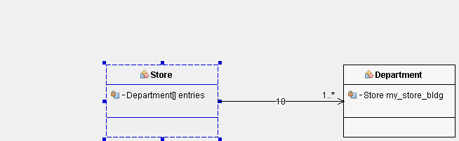

2.)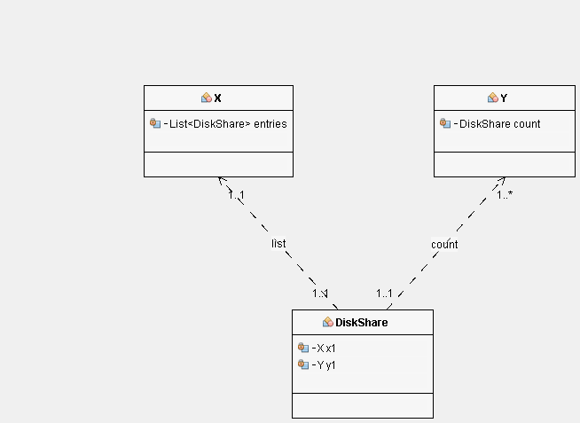

3.)

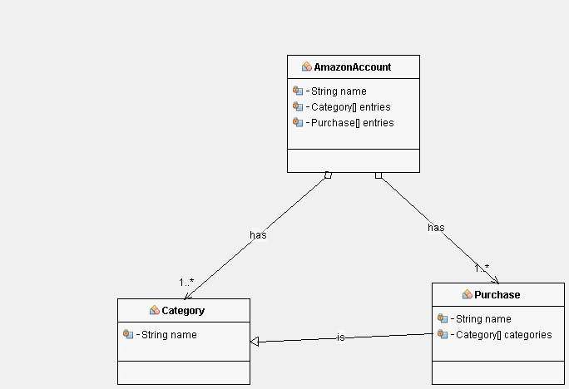

4.)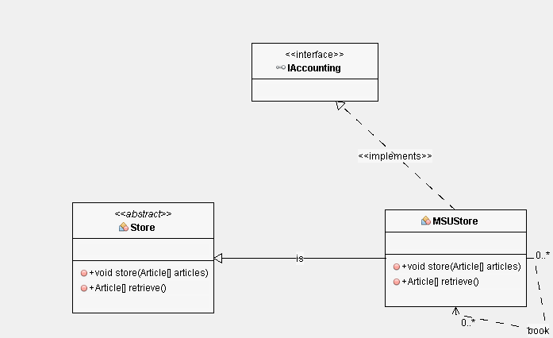

**Part B:**

|  |  |  |  |  |
| --- | --- | --- | --- | --- |
| **LifeCycle** | **Properties** | | | **Type of project** |
|  | **Present** | **Absent** | **N/A** |  |
| Waterfall Model | A, SD, I, T,D, M | E, DS |  | A new application for a large company that is built on existing technology. |
| Iterative Model | SD, D, T, I | A, M, E, DS |  | This is best suited for a team that is working on a new or evolving technology. It helps them understand as they create. |
| Spiral Model | All |  |  | Best suited for high-risk problems, and problems where the consumer doesn’t quite know what they want. That way the SEs can adapt to the change quickly with this method |
| V-Model | SD, T, D | A, I, M, E, DS |  | Best suited for Nondynamic and well understood requirements. This is used a lot in the medical field |
| Big Bang Model |  |  | All | Ideal for small team projects and/or ones with requirements that are not fully understood |
| Agile Model | A, T, SD, D, E |  | DS | No real planning, better used for projects that are growing or changing rapidly due to customer feedback |
| RAD Model | I, D,T |  | A,SD,M,E,DS | Best suited for problems that can be broken down on modules that can be worked on and then pieced back together |
| Software Prototype | T,D,E,I | SD,DS, | A,M | Best suited for applications that have a high level of user interaction, such as sites that need people to fill out forms and stuff like that |

A = Analysis, SD= Software Design, I = Implementation, T = Testing, D = Deployment, M = Maintenance, E = Evaluation, DS = Disposal

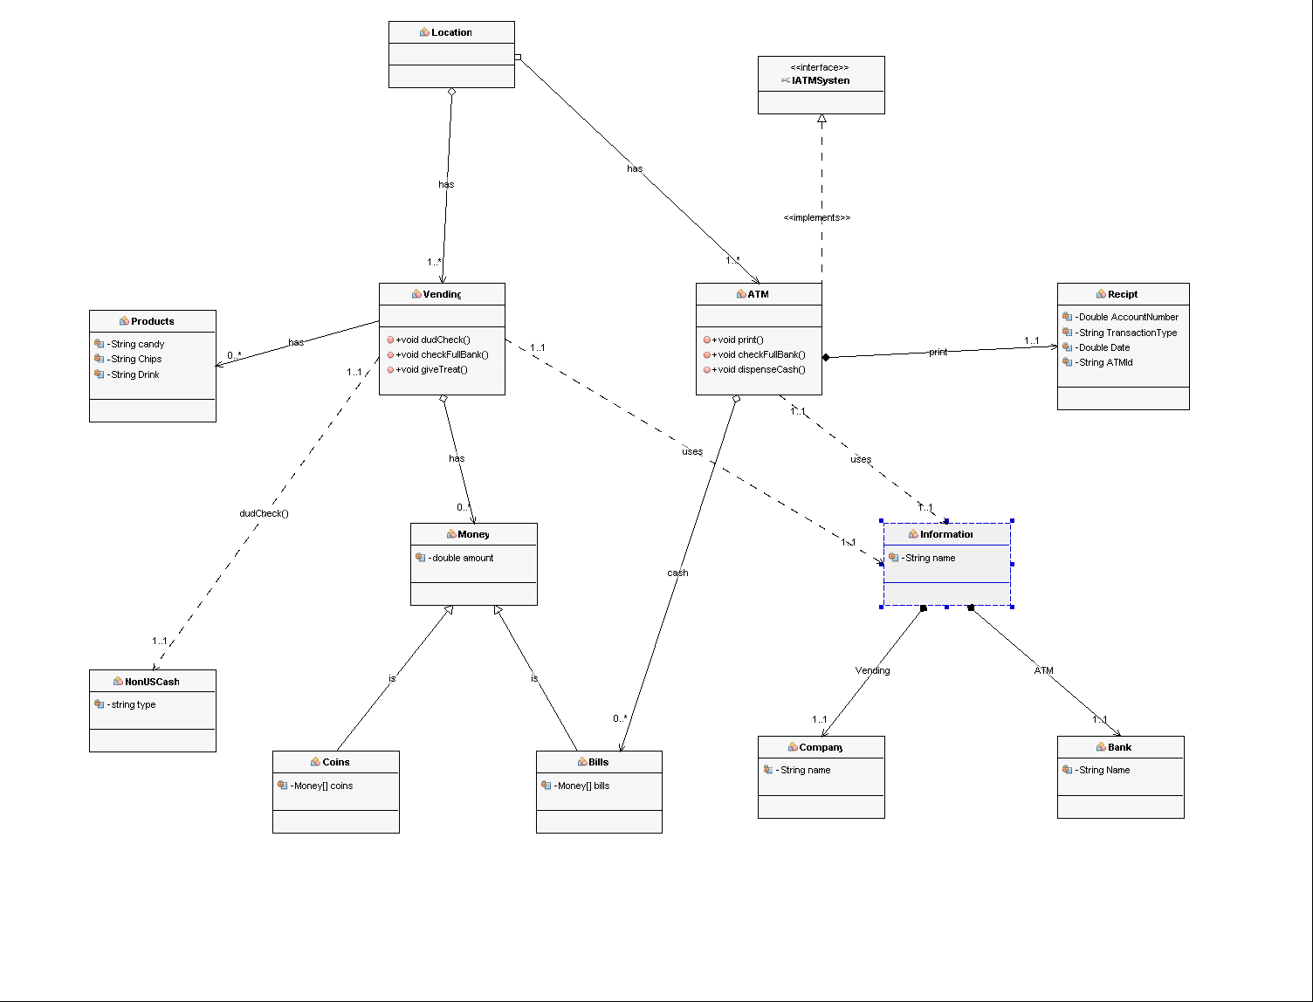**Part C:**